**Fuzolo Website → Feedbacks**

**1 : - Login**

→ Home Page

**2 : - Squad : - User Dashboard**

→ Remove chat btn

→ move to bottom

→ Remove button details to be re-discussed later

**3 : - Booking History : - Dashboard**

→ show last 5 booking instead of 1

→ remove view invoice

→ Add Sport Name

→ Remove ratings

→ move to Top

→ Right Side Add Book btn

**4 : - Employee Management : - Admin**

→ Remove Footer From Admin Panels

> Rename modules to Access

→ list of Employees of all venues(filter to venue wise as well)

**5 : - Ground Management : - Admin**

→ Remove Available Slots

→ Make it start - end timings

→ move maintenance part to manage booking module

**6 : - Admin Dashboard : - Admin**

→ Rename Ground to Venue

**7 : - Coupon Management : - Admin**

→ Add maxValue (for percentage type select) example : 50% off upto 200(so max value of discount is 200 if 50% of certain amount is more than that)

→ Rename Tiers to Customer Category

→ Make Dropdown for Tiers

→ multiple tiers can be selected at once (for now we will keep it All Users and Customer Categories 1 - 9 )

→ Type : - Both ( Flat and Percentage )

**8 : - Booking Management : - Admin**

→ Add venueId

→ Make date and time separate

→ incase of refund we have mention if refund has done in Fuzolo Points or Cash

→ ground wise minimum slot book

**9 : - Payment & Finance : - Admin**

→ Rename initial to Advance

→ Rename Remaining to Outstanding

→ only Transaction metrics should be there in this . avoid others

→ max time for updation of things properly game time + 24 hrs

**10 : - Tournament Page - User**

→ design as per this image

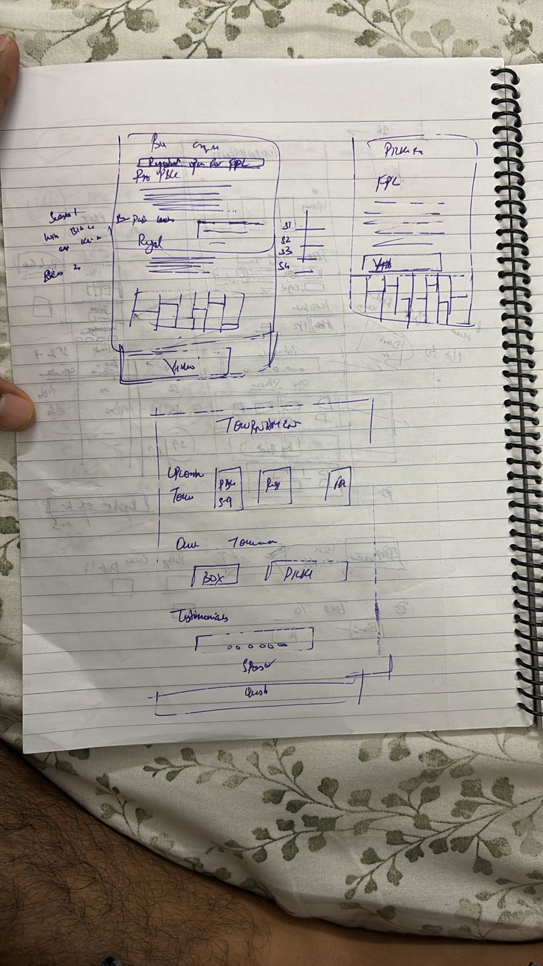

Order of things :-

Our tournaments - photos ans season wise details

Testimonials

Sponsors

questions/ queries form

**10 : - Other Changes**

→ **Login Page : -** Add Enter your WhatsApp Number

-> **OTP page : -** Add Fuzolo

→ **Profile Page : -** Disable phone number

→ **Edit Profile** → New Number → New Otp

→ **Otp Resend : -** Limit The Number

→ **Login page : -** Add captcha in

→ **Select Slot :-** Remove GST , Open Dialog Box When Click On Apply coupon

and show all the coupons, user can select only one coupon at a time

→ **Setup Profile page** - Phone number should be freezed(uneditable) ig logged in using number same in case of google sign in details must be freezed.

→ Razorpay Acc 1 and 2 renamed to Elite Sports and Fuzolo (to be discussed later)

→ Venue Manager Number to be shown at user end somewhere

→ venue manager and ground manager's role are different . to be visible to user

→ slots booking should be in continuation only .

Min slot 1 hour — max 3-4 hrs

After one slot selection of 1 hour … user can select a 30 mins slot as well.

**\*\*\* → No Footer in any Admin panel page\*\*\***